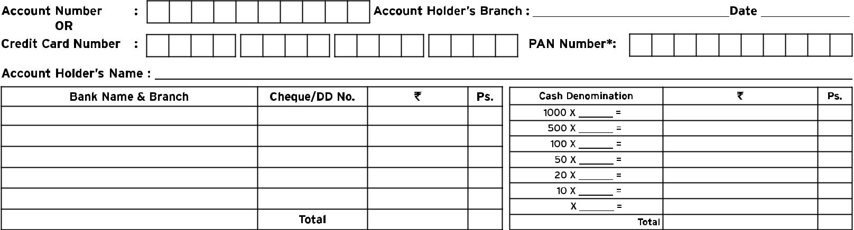
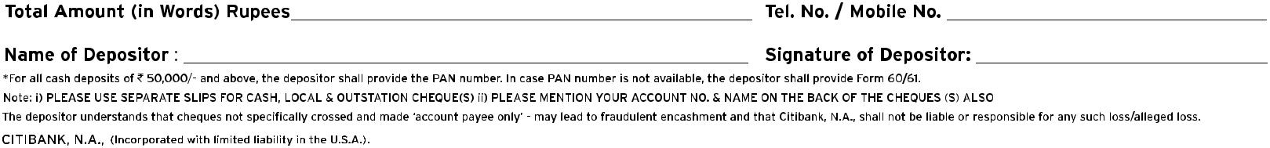
CASH DEPOSIT SLIP TEMPLATE

