 |  |  |  |  |  |  |  |  |  |  |  | Custom Request For Quote Form
E-mail:
address:
city: |  |  |  |  |  |  |  |  |  |  |  |  |  |  |  |  |  |  |  |  |  |  |  |  |  |  | state/province:
postal code: |  |  |  |  |  |  |  |  |  |  |  |  |  |  |  |  |  |  |  |  |  |  |  |  |  |  | country:
phone:
company name:
ITEMS going inside case:
case APPLICATION: (Check All That Apply)
 | equipment/STORAGE |  |  |  |  |  |  |  |  |  |  |  |  |  |  |  |  |  |  |  | medical |  |  |  |  |  |  |  |  |  |  |  |  |  |  | sample/DEMO |  |  |  |  |  |  |  |  |  |  |  |  |  |  |  |  | SHIPPING |  |  |  |  |  |  |  | technician
 | TOOL PALLETS |  |  |  |  |  |  |  |  |  |  |  |  |  |  |  |  |  |  |  | I DON’T KNOW |  |  |  |  |  |  |  |  |  |  |  |  |  |  |  |  |  |  |  |  |  | OTHER
TYPE OF CASE: (Check All That Apply)
 | aluminum |  |  |  |  |  |  |  |  |  |  |  |  |  |  |  |  |  | BLOW MOLDED |  |  |  |  |  |  |  |  |  |  |  |  |  |  |  |  |  |  |  |  |  |  |  | MOLDED |  |  |  |  |  |  |  |  |  |  |  |  |  |  |  | SOFT SEWN
 | foam filled |  |  |  |  |  |  |  |  |  |  |  |  |  |  |  | TOOL CASE/TOOL ROLLS |  |  |  |  |  |  |  |  |  |  |  |  |  |  |  |  |  |  |  |  |  |  |  |  |  | watertight |  |  |  |  |  |  |  |  |  |  |  |  |  |  |  | I DON’T KNOW
 | OTHER

estimated CASE quantities NEEDED:

estimated weight of ITEMS in case:

estimated usable space of CASE:

length width depth I DON’T KNOW

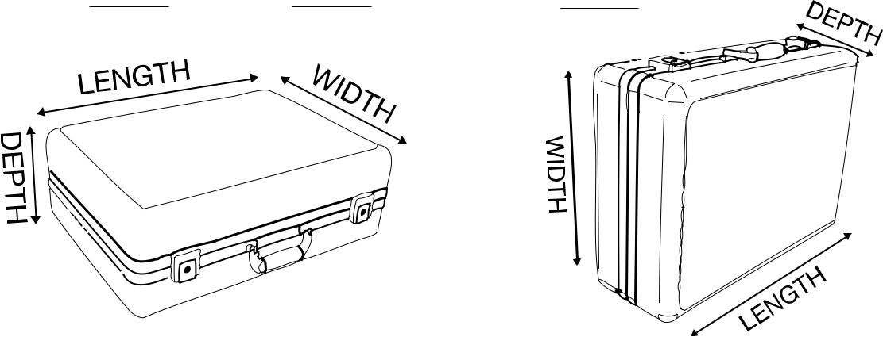

1

WHEEL & HANDLE (RETRACTABLE HANDLE/TRANSPORT WHEELS) REQUIRED:

yes no I DON’T KNOW

LOCKING FEATURE REQUIRED:

yes no I DON’T KNOW

foam proTECtion required:

yes no I DON’T KNOW

color:

color availability may vary based on type of case required

other:

2

