Annual Payroll Report

Year Ended December 31, _______
Employer __________________________________________

CLASSIFICATION OF OPERATIONS

CLASS

CODES

Total Payroll for
Twelve Mos. Ending

December 31, _________

Tree Pruning and Spraying, incl. Drivers |  |  | 0106
Machine Shop |  |  | 3632
Street or Road Construction, paving, resurfacing, incl. Drivers |  |  | 5506
Street or Road Construction, clearing, excavation, incl. Drivers |  |  | 5507
Sewer Construction, all operations, incl. Drivers |  |  | 6306
Gas & Water Main & Connections-Construction, incl. Drivers |  |  | 6319
Aircraft Ground Employees |  |  | 7403
Gas Works, all operations (excl. construction of bldgs/gas holders) |  |  | 7502
Waterworks Operation, all employees, incl. Drivers |  |  | 7520
Sewerage Disposal Plant Operation, incl. Drivers |  |  | 7580
Garbage Works-Reduction or Incineration |  |  | 7590
Firefighters, incl. Drivers |  |  | 7710
Law Enforcement Officers, incl. Drivers & Emergency Communication Technicians |  |  | 7720
Automobile Repair Shops-all employees, incl. Drivers |  |  | 8380
Engineers or Architects-not engaged in actual construction |  |  | 8601
Clerical Office Employees (Court clerks, Comm. Atty., etc.) |  |  | 8810
Dog Warden (kennel), incl. Drivers |  |  | 8831
Hospital-Professional Employees |  |  | 8833
Care, custody & maintenance of bldgs. & grounds |  |  | 9015
Hospital-All employees other than professionals |  |  | 9040
All other Library Employees |  |  | 9101
Parks & Recreation Areas-All operations except new construction |  |  | 9102
Cemetery Employees |  |  | 9220
Sewer Cleaning, Street Cleaning, & Snow/Ice Removal & Drivers |  |  | 9402
Garbage, Ashes or Refuse Collection, incl. Drivers |  |  | 9403
Tax Collectors, Inspectors, Farm & Home Demonstration Agents |  |  | 9410
Welfare, Case Workers-not office |  |  | 9411
Space for other classifications available on reverse side
 | Subtotal – this page
 | Subtotal – 2nd page
 | Total of all payroll

Signed this day __________________ by ________________________________________________________________________________
Date Signature of Representative and Title

of ______________________________________________________________________________________ ________________________
Name and Address of City, Town or County Fed. Tax ID#

This day ______________________________ personally appeared before me, acknowledged their signature, and made oath that the foregoing
Report is correct.

Given under my hand and notarial seal this _________ day of ______________________, _________.

Signature of Notary

SEAL
My commission expires _______________________

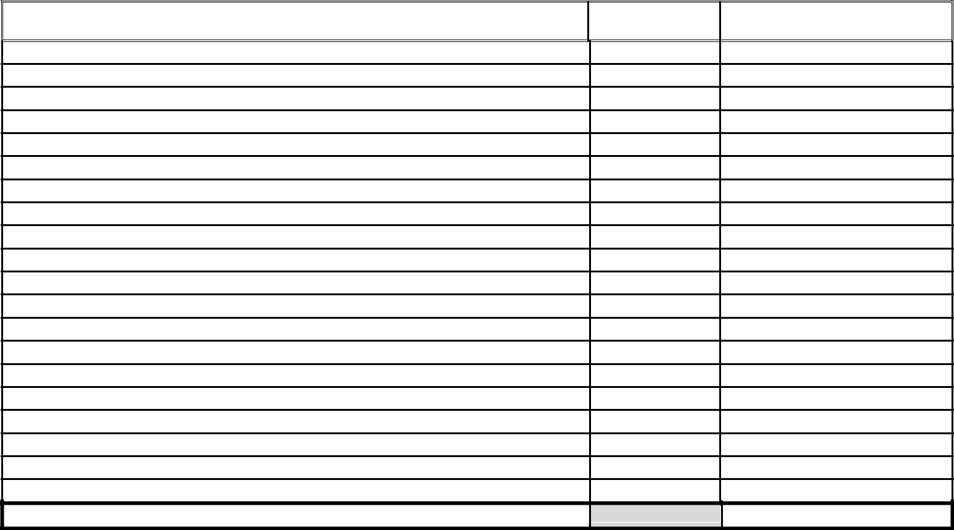
CLASSIFICATION OF OPERATIONS – continued
CLASS

CODES

PAYROLL

AMOUNT

Subtotal – 2nd page

Note 1: The extra remuneration paid for overtime may be deducted; e.g. if time and a half paid for overtime, the half may be deducted.

Note 2: New construction work and alterations done by employees of the municipality must be reported under the various construction classifications applicable, such as masonry, plumbing, sheet metal work, etc.

Note 3: If you need to report for flying crew the Classification Code is 7421, however, when using 7421 you must also report the number of passenger seats using Classification Code 0088.

Please enter the name and telephone number of the person to contact if we have any questions regarding this report. Please print.

_____________________________________________________________ _____________________
Name of Contact Telephone #

