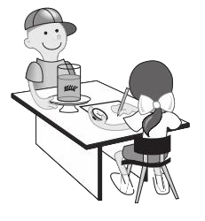

Homeschool Schedule

Monday

Tuesday

**Wednesday**

**Thursday**

Friday

8am

9am

10am

11am

12pm

1pm

2pm

3pm