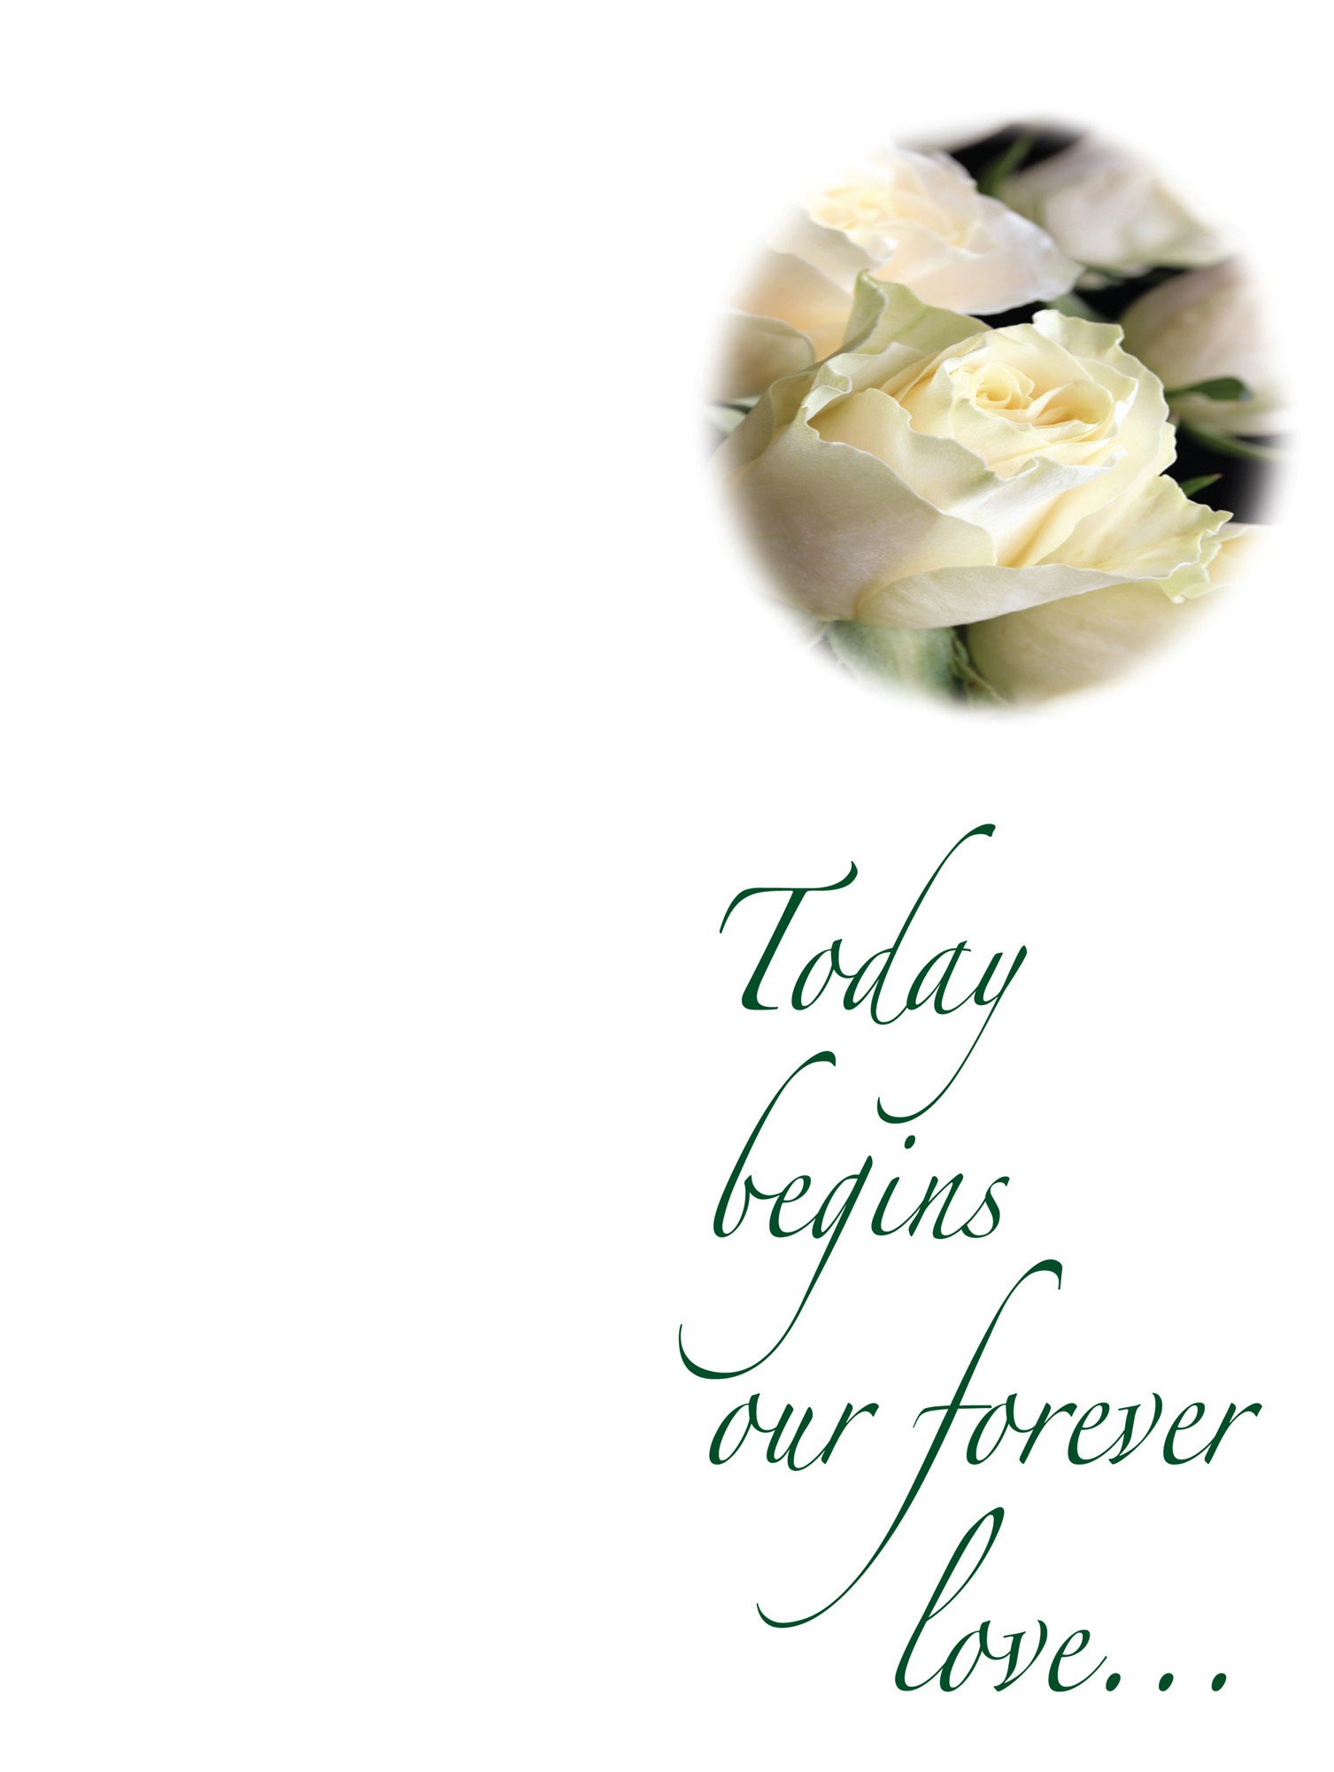

Directions to reception:

Bride’s Full Name
and
Groom’s Full Name

Date: 00.00.000 Time: 00:00 am
Ceremony Site

THE WEDDING CEREMONY

PRELUDE

SOLO
Song Name

SEATING OF THE GRANDPARENTS

SEATING OF THE PARENTS

SOLO
Song Name

PROCESSIONAL
GREETING MINISTER

MARRIAGE VOWS

EXCHANGE OF RINGS
SOLO
Song Name

LIGHTING OF THE UNITY CANDLE
PRAYER

PRONOUNCEMENT
*RECESSIONAL

*Please stand and wait until ushers escort
parents and grandparents from church.

The Bride’s Parents
The Groom’s Parents

The Bride’s Grandparents
Great-Grandparents
The Groom’s Grandparents

THE WEDDING PARTY

Minister
Maid of Honor
Bridesmaids
Bridesmaids
Bridesmaids
Flower Girls
Best Man
Groomsmen
Groomsmen
Ring Bearer
Ushers
Ushers
Ushers
Ushers
Organist/Pianist
Soloists

You are invited to reception
Immediately following ceremony

