CUSTOMER PROFILE SHEET

CUSTOMER NAME

Primary Mailing Address: |  | Primary Shipping Address (if different):
Address |  | Address
City |  | City
State | Zip Code | State | Zip Code

 | Purchasing Contact |  |  |  |  |  |  |  |  |  |  |  |  |  |  |  |  |  |  | Quality Contact
 | Email |  |  |  |  |  |  |  |  |  |  |  |  |  |  |  |  |  |  | Email
 | Phone |  |  |  |  |  |  |  |  |  |  | Fax |  |  |  |  |  |  |  | Phone |  |  |  |  |  |  |  | Fax
 |  |  |  |  |  |  |  |  |  |  |  |  | PRODUCTION AND PACKAGING SPECS
 |  | Max Skid Weight for Sheet |  |  |  |  |  |  |  |  |  |  |  |  |  |  |  |  |  | Coil I.D. Min: |  |  |  |  |  |  |  |  | Coil I.D. Max:
 |  | Max Skid Weight for Coil |  |  |  |  |  |  |  |  |  |  |  |  |  |  |  |  |  | Coil O.D. Min: |  |  |  |  |  |  |  |  | Coil O.D. Max:
 |  | Max Coil Weight: |  |  |  |  |  |  |  |  |  |  |  |  |  |  |  |  |  | Paper Interleave Required
 |  | PVC Requirements, if yes please select |  |  |  |  |  |  |  |  |  |  | B&W |  |  | Clear |  | Laser Nitto |  |  |  | No Preference |  |  |  | Other, Please Specify
 | Coil Eye Horizontal |  |  |  |  |  | Coil Eye Vertical
 | Payoff Reel Clockwise |  |  |  |  |  |  |  |  |  | Payoff Reel Counter Clockwise |  |  |  |  |  |  |  |  |  |  | Paper Wrap Coils:
 |  | Certifications Required: |  |  |  |  |  |  | With Shipment: |  |  |  |  |  |  | With Invoice: |  |  |  |  |  | Mill Certs: | Domestic Only:
 |  | Line Marking Required: |  |  |  |  |  |  | Coil |  |  |  | Sheet |  | Heat Number |  |  |  |  |  | Coil Number
 |  | SKID REQUIREMENTS:
 |  |  | SRM Standard Skid |  |  |  |  |  |  |  |  |  |  |  |  |  | If Custom, Please Explain Below (there maybe an additional charge for custom skids)




CUSTOM SKID

REQUIREMENTS:

FREIGHT AND SHIPPING INSTRUCTIONS

Receiving Hours:

Truck Type: Closed Van Flatbed Open Top

Load Position: Rear  Side Rear-Side Open

Unload Type: (Sheet) Fork Lift Overhead Crane

Receiving Days:

FOB POINT:

Unload Type: (Coil) Fork Lift Overhead Crane
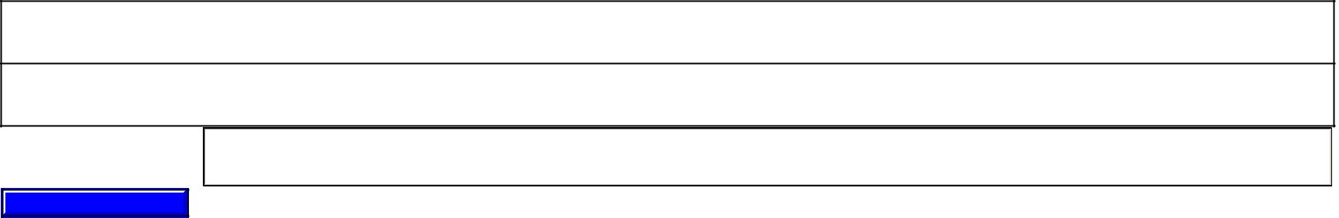

If an Appt is required for Delivery,
Need contact name and number

Receiving Contact Name and Phone
Number, for freight carrier and drivers

Special Instructions

Reset Form

