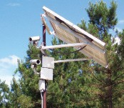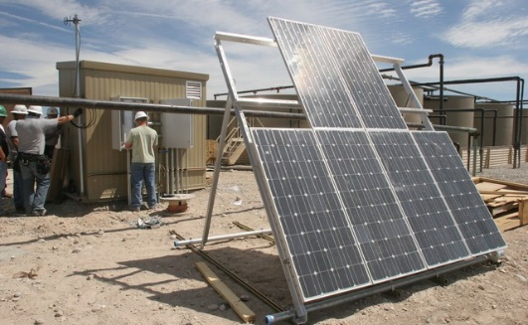

Capability Statement

Core Competencies

SunWize Power & Battery is a small business enterprise that designs and builds reliable, stand-alone industrial power solutions and electronic assemblies for integration into OEM products and off-grid field applications. With over 20 years of proven reliability

in extreme environments, our solar, battery backup, and hybrid power systems are pre-engineered, assembled and tested for easy installation and minimal maintenance.

We also offer a broad spectrum of remote industrial power system components, such as electrical components, batteries, solar modules, enclosures, and solar module mounts.

**CAGE code:**

77K75

**Products**

**Services**

•

•

•

•

•

•

Solar electric power systems Uninteruptible power sources Battery back-up systems Wholesale system components

DC and AC power conditioning systems Solar/Generator/Hybrid systems

•

•

•

•

•

Contract manufacturing

Power system specification & design Engineering & consultation

Solar module manufacturing Sheet metal manufacturing

**DUNS #:**

079520886

**NAICS Code:**

221114

221118

334413

335122

335129

335312

335911

423690

541330

**Past Performance**

Our business focuses on working closely with our customers to understand power system requirements and provide high quality, comprehensive, reliable, and cost- effective power systems to meet customer needs. We are constantly evaluating our approach to ensure we are using industry-leading products and the highest standards when building our systems. We are committed to excellence in everything we do, which is why our customers continually come to us with their power needs.

**Government**

**Commercial**

**International**

•

•

•

•

•

National Park Service Department of Transportation Department of Defense Bureau of Land Management

Navajo Tribal Utility Authority

•

•

•

•

•

Chevron Honeywell Verizon Emerson

Lockheed Martin

•

•

•

•

•

ADCO

Bearcom Unavco

Burhani Engineers

SAIC

**Differentiators**

Our real point of difference is the ability to collaborate with customers and partners to provide custom battery-based power solutions for remote locations, suited to meet very different application needs.

•

•

•

Close relationships with top-tier vendors for reliable components Experienced Project Managers & Engineering team

Documented quality control manufacturing program with pre-shipment quality control testing of all manufactured power systems

Fast design and manufacturing of high quality custom aluminum and steel battery and electronics enclosures

•

**Headquarters:**

1337 Main Street

Philomath, OR 97370

**Contact:**

(866) 827-6527

[power@sunwize.com](mailto:power@sunwize.com)

**Website:**

[www.sunwizepower.com](http://www.sunwizepower.com/)

Contact Us: