 | 
 | HOME INSPECTION CHECKLIST
 | Building: North Business Tower, 104C East Road, 25 87 Fulmingtown Date: November 17, 2025
 | ✔ |  | STRUCTURAL INTEGRITY & EXTERIOR ENVELOPE |  | 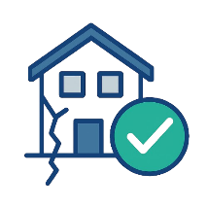
 |  |  | Inspect exterior walls, balconies, roof surfaces, stairwells, and façade elements for cracks, corrosion, or water damage. Check railing stability, foundation shifts, and signs of wear that could compromise safety or long-term durability. Include shared outdoor areas, retaining walls, parapet edges, visible joints, and any exposed structural steel or concrete.
 | ✔ |  | ENTRYWAYS, DOORS & EMERGENCY EXITS |  | 
 |  |  | Review main entrances, apartment doors, hallway access points, and fire exits. Confirm door alignment, lock function, and unobstructed egress routes. Ensure emergency exits are clearly marked, illuminated, and accessible. Inspect intercoms, door closers, signage visibility, doorframe integrity, floor-level lighting, and weatherproofing of external doors.
 |  |  | ELECTRICAL SYSTEMS & FIXTURES |  | 
 |  |  | Inspect hallway lighting, switchboards, visible wiring, and outlet condition in shared zones. Test emergency lighting, circuit breakers, and voltage stability. Confirm tenant units have safe electrical access. Check for exposed wires, overloaded sockets, and compliance with safety codes. Include meter boxes, backup systems, fuse labeling, and grounding verification.
 |  |  | PLUMBING, DRAINAGE & WATER SUPPLY |  | 
 |  |  | Check water pressure, pipe condition, fixture operation, and drainage flow in common areas and sample units. Look for leaks, moisture damage, and mold. Confirm hot water availability, valve access, and meter readability. Include utility rooms, basement plumbing lines, rooftop tanks, sump pumps, exposed pipe insulation, and signs of backflow or clogging.
 |  |  | HVAC & VENTILATION SYSTEMS |  | 
 |  |  | Assess heating and cooling units, ductwork, and airflow in stairwells, hallways, and sample apartments. Check thermostat accuracy, filter cleanliness, and system responsiveness. Confirm bathroom and kitchen ventilation is functional. Include rooftop condensers, intake vents, shared mechanical rooms, service shafts, noise levels, and signs of condensation or blockage.
 |  |  | SAFETY EQUIPMENT & SURVEILLANCE |  | 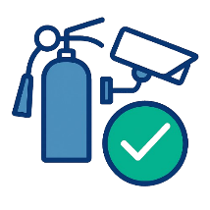
 |  |  | Verify fire extinguishers, smoke alarms, carbon monoxide detectors, and sprinkler systems in all required zones. Review CCTV coverage, access control panels, and alarm systems. Confirm maintenance logs are current and that all safety devices are tested and documented regularly. Include stairwell lighting, emergency signage, battery backups, and tamper-proof seals.
 | www.mycompany.com • officeinfo@mycompany.com • (555) 123 456 7890

